 | Human | Intermediate | Gorilla
Foramen Magnum | 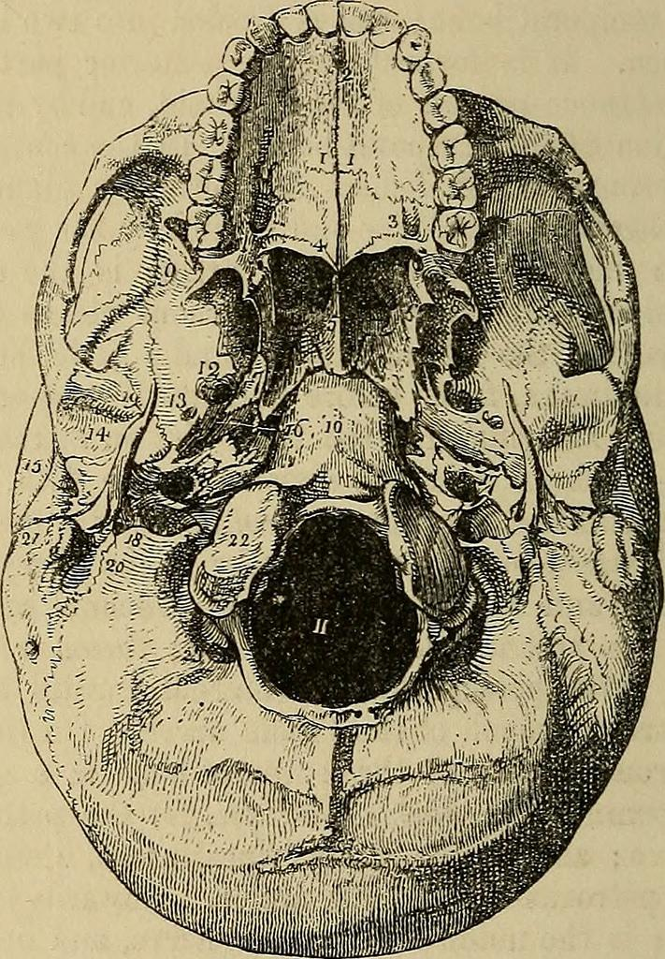  Towards the middle |  | 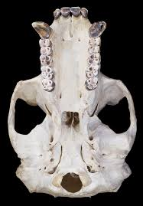  Towards the back
Teeth size | Small | In between, or varies with different teeth | Large
Face angle | Vertical | A small angle to the face | Angled
Sagittal crest | Absent | A small sagittal crest | 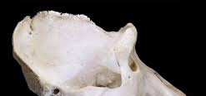  Present
Chin | Present |  | Absent

